How to Upgrade Kilolink Server Free to Kilolink Server Pro: A Step-by-Step Guide
Foreword
Now we have released the latest KiloLink server, the name is KiloLink Server Pro, which is the combination of KiloLink server free and KiloLink bonding server, and it also supports the functions of device management and multi-link aggregation.
Since early customers have already deployed KiloLink server free and KiloLink bonding server, and at the same time there are already several devices linked to the server, if the server is completely redeployed, it may be necessary to re-register the devices and connect them to KiloLink Server Pro, which will increase the difficulty of updating and the operation time of the customers.
The following tutorial can help customers to retain the data loss of KiloLink server free and upgrade the server to KiloLink Server Pro without any loss. devices (e.g. N3\N4, E1\E2, etc. which can be automatically connected to KiloLink Server Pro) will be switched to connect to KiloLink Server Pro without any loss and do not need to repeat the operation again.
Server situation
- The data of KiloLink server free is compatible with KiloLink Server Pro, KiloLink Server Pro can directly access the data of KiloLink server free to achieve data interoperability, avoiding re-registration and connection, please refer to the following steps to backup data or directly access the historical data for installation.
- The data of KiloLink bonding server and KiloLink Server Pro are not interoperable, the new KiloLink Server Pro adopts a brand new architecture, the data information can not be read synchronously. Therefore, if you have already installed KiloLink bonding server, please refer to step 4 of this tutorial to install KiloLink Server Pro directly, and follow the prompts to delete KiloLink bonding server during the installation process.
data backup
Data backup supports two methods: (refer to step 3 for specific steps)
Method 1: Backup data files
Method 2: Access to historical data
Prescription
Step 1: Login to the server using SSH and give administrator privileges
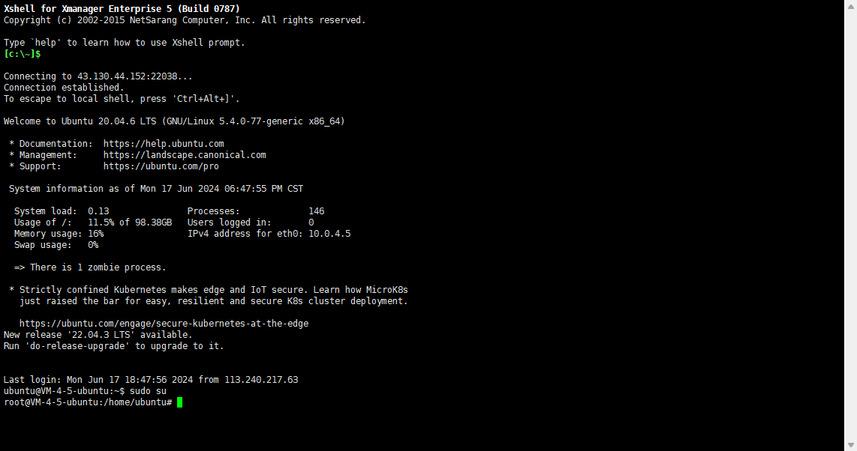

Step 2: Check the storage path of the KiloLink server free data.
command：docker inspect kilolinkserverfree
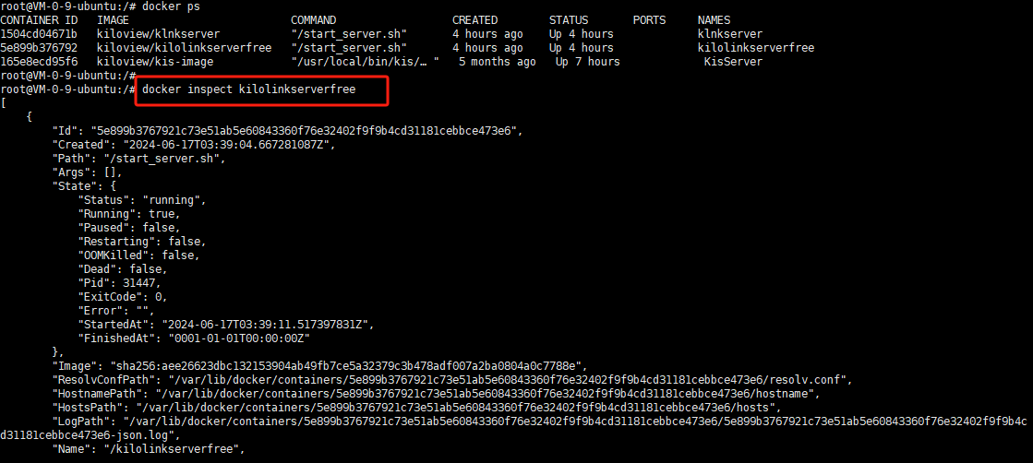
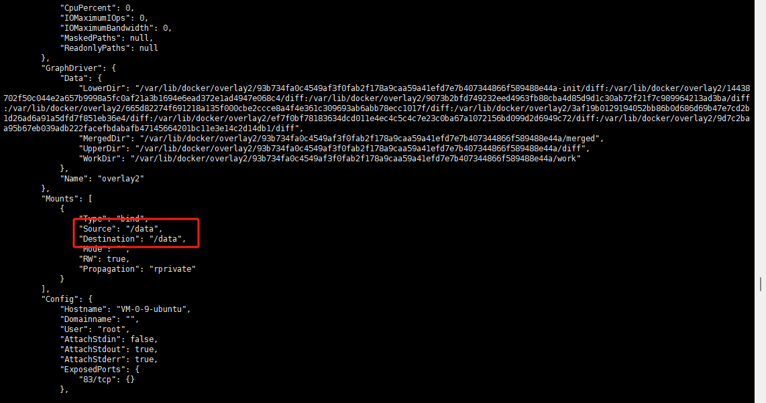
note：he default storage path for KiloLink server free data is: /data

Step 3: Backup data files or directly retrieve historical data
Method 1: Backup data files;
If backed up to /data_back (this file name can be customised by the customer, if changed please use the same file path in future)
1. Use the command to backup data files： cp /data /data_back -rf
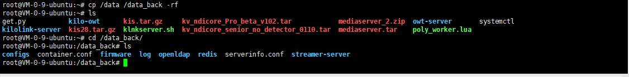
2. Copy the file data to the installation directory, the default installation path of KiloLink Server Pro is: /root/kilolink-server.
At this point just create /root/kilolink-server and copy the files to the default path.
Command a:mkdir /root/kilolink-server
Command b:cp -rf /data_back/* /root/ kilolink-server
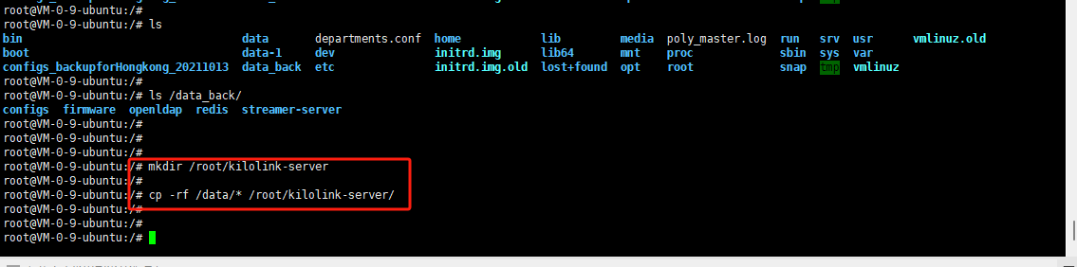

Method 2: Direct access to historical data
Change the installation path of KiloLink Server Pro to /data, KiloLink Server Pro will automatically fetch the file data under the /date directory.
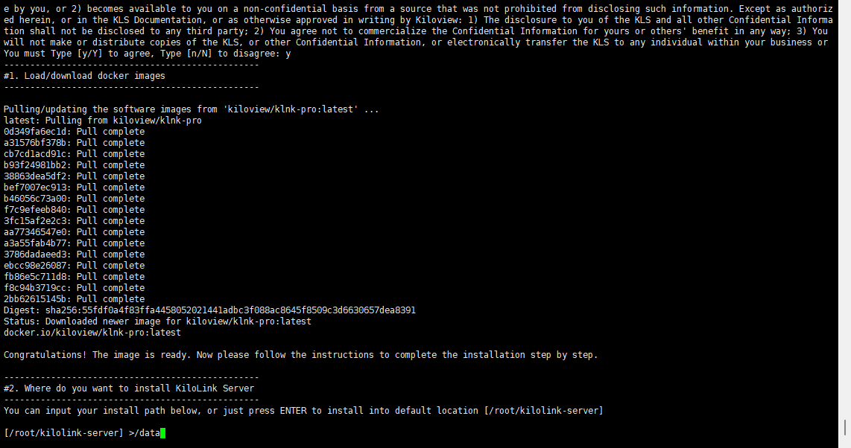
Step 4: Installation of KiloLink Server Pro
1. Run the command:
/bin/bash <( curl -fsSL https://github.com/kiloview/klnk-server/raw/main/install.sh )
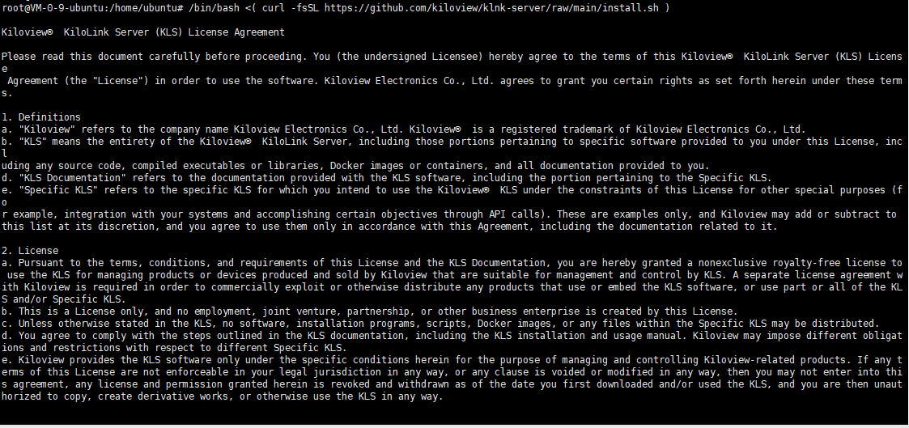

2. Delete the installed KiloLink server free and KiloLink bonding server according to the prompts. The following is the list:
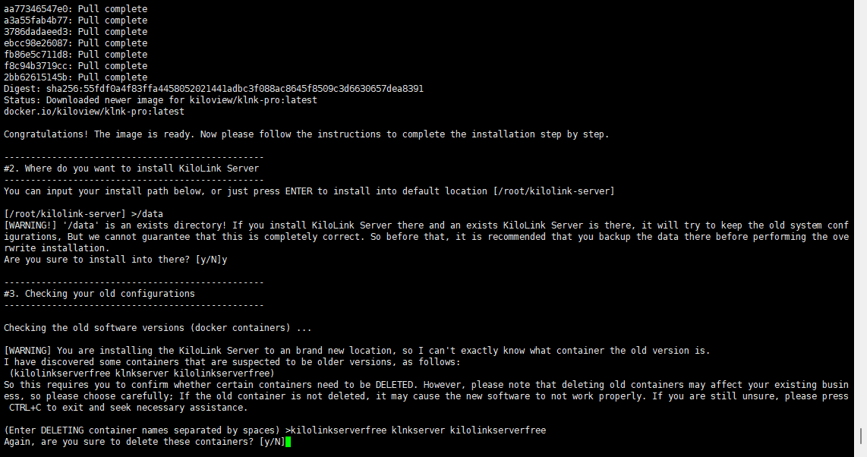备Note： The backup method shown in this image is method 2 of the step-by-step procedure, which directly retrieves the data in /data.

3. Installation completed.
After confirming the port and IP address, the prompt ENJOY IT indicates that the installation is complete.
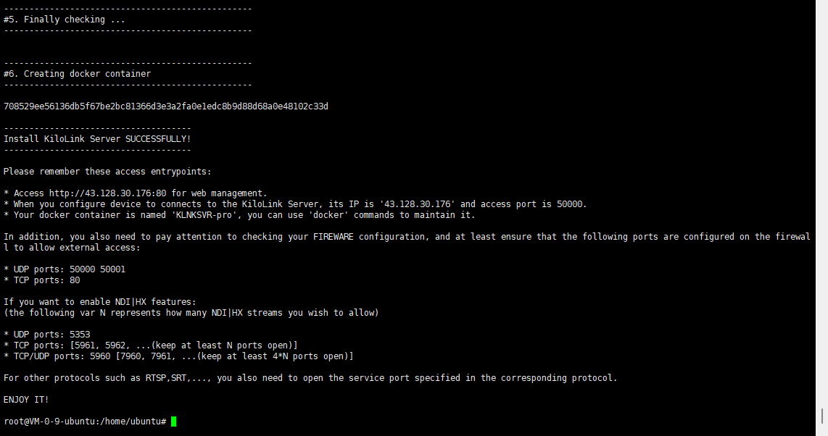

Step 5: Visit the web
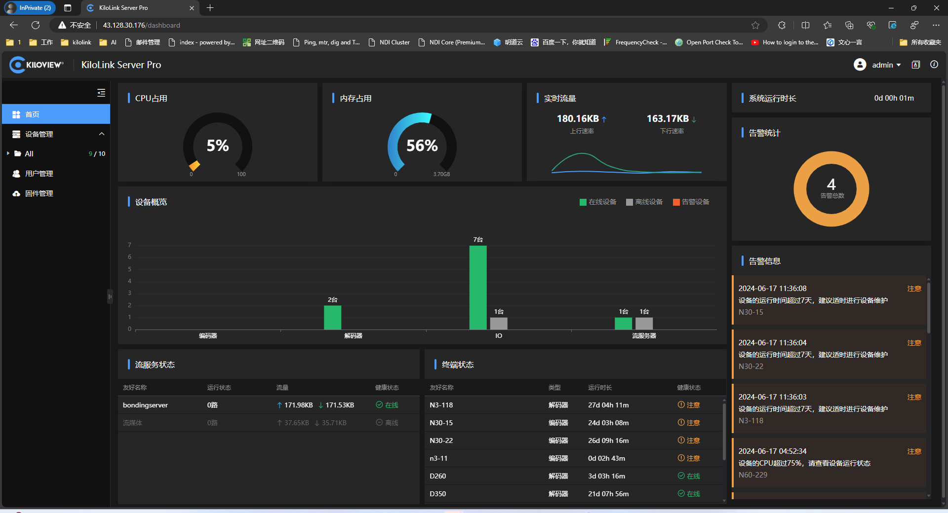

Step 6: Check device data retention and whether the device is online
Check whether the device which was connected to KiloLink server free earlier is already online, the following figure shows the device which was connected to KiloLink server free earlier, and now the device is automatically connected to KiloLink Server Pro after following the steps to retrieve the data.
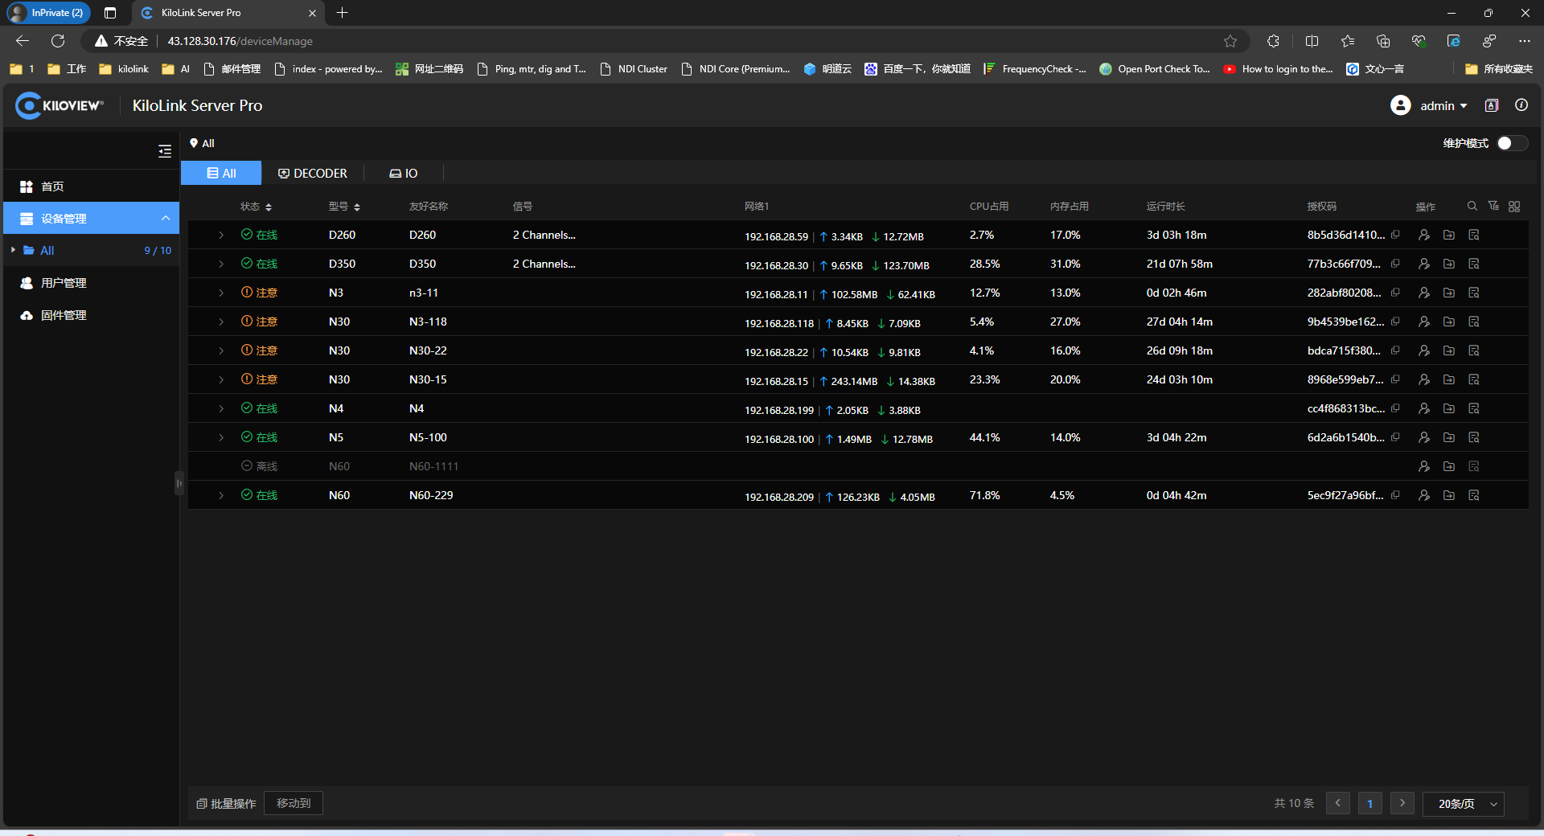
Step 7: Update Firmware
The firmware of the device will be updated at the same time. After the update, the device will be more stable to connect to KiloLink Server Pro, and at the same time, it will support the functions of one-click reboot and one-click upgrade.
For more firmware downloads, please visit the official website: https://www.kiloview.com/en/support/download/

If your problem still can't be solved, please send an email to Kiloview technical support at support@kiloview.com. Our engineers will assist you to solve the problem.

